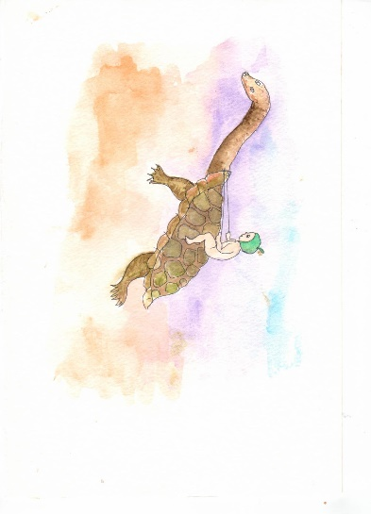

May Gibbs Inspired Art Exhibition
May 2024 at The Arts Centre Cootamundra
ENTRY FORM
(Please type or print clearly and bring the completed form with you when delivering your artwork.)
Artist Name:
Street Address:
Postal Address:
City / Town: | Postcode:
Phone / Mobile:
Email:
Website or social media details (for flyer):
Exhibition Flyer:
Your name, phone number, email address and website / social media details will be included in the Exhibition Flyer so any interested purchasers can contact you directly. If you do NOT want any of these details included please indicate this below.
DO NOT INCLUDE
- Artworks are to be delivered to TACC on Tuesday 14th of May 2024, between 12pm and 3pm.
- Artworks are to be collected from TACC on Thursday 30th of May 2024 between 12pm and 3pm.
I declare that the works submitted by me are my own original works.

Signed: | Date:
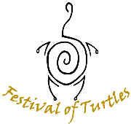
This Exhibition is part of the “Festival of Turtles”
Celebrating 20 Years of TACC in 2024

Artist Name Total Number of Artworks Entered

ARTWORK #
Title:
Medium:
Dimensions:
Short description of artwork:

ARTWORK #
Title:
Medium:
Dimensions:
Short description of artwork:

ARTWORK #
Title:
Medium:
Dimensions:
Short description of artwork:

